Charles Valentine

Homework 2

9/16/2016

Problem 1

1. See code
2. See code
3. Top 3 Genes with the largest mean expression in ALL patients:

[1] "GB DEF = Chromosome 1q subtelomeric sequence D1S553"

[2] "37 kD laminin receptor precursor/p40 ribosome associated protein gene"

[3] "RPS14 gene (ribosomal protein S14) extracted from Human ribosomal protein S14 gene"

1. Top 3 Genes with the largest mean expression in AML patients:

[1] "GB DEF = mRNA fragment for elongation factor TU (N-terminus)"

[2] "GB DEF = HLA-B null allele mRNA"

[3] "Globin, Beta"

Problem 2

1. See attached
2. See attached
3. 0.9174976
4. 123
5. See below

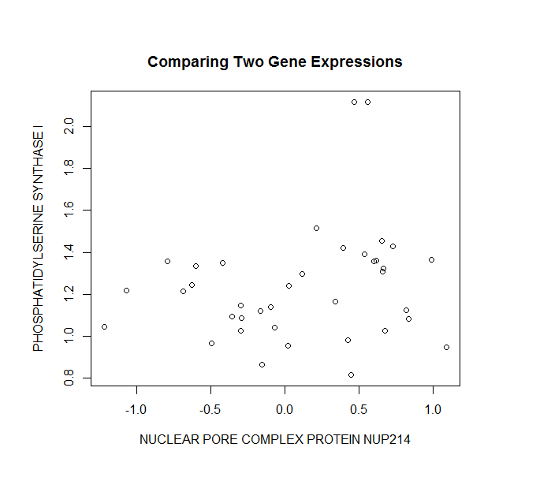

Problem 3

1. See figure below

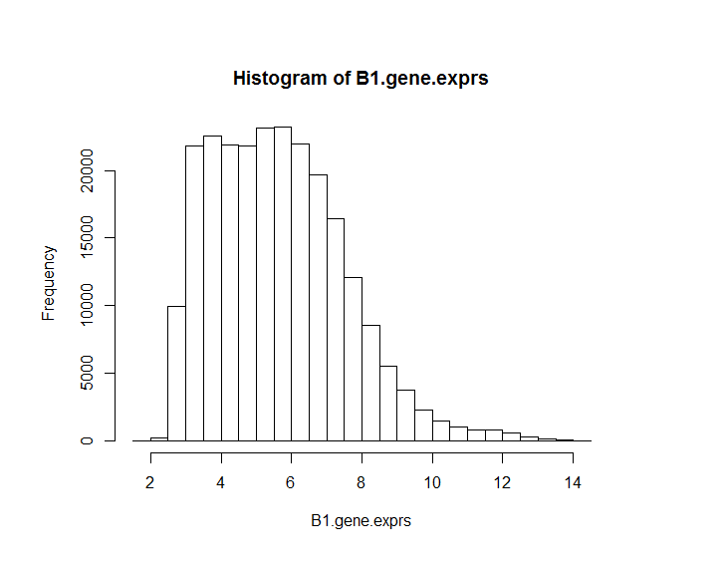

1. See code
2. Top three gene IDs with the largest mean expression in stage B1 ALL patients:

[1] "AFFX-hum_alu_at" "31962_at" "31957_r_at"

Problem 4

1. Data.frame
2. See figure below. I used a different, more familiar, method of plotting.

